Sequence:
1 MGRSHQISDW DPEDSVAWEA GNKFIARRNL IWSVAAEHVG FSVWSLWSVM VLFMPTSVYG
61 FSAGDKFLLG ATATLVGACL RFPYTFATAK FGGRNWTIFS ALVLLIPTVG SILLLANPGL
121 PLWPYLVCGA LAGLGGGNFA ASMTNINAFF PQRLKGAALA LNAGGGNLGV PMVQLVGLLV
181 IATAGDREPY WVCAIYLVLL AVAGLGAALY MDNLTEYRIE LNTMRAVVSE PHTWVISLLY
241 IGTFGSFIGF SFAFGQVLQI NFIASGQSTA QASLHAAQIA FLGPLLGSLS RIYGGKLADR
301 IGGGRVTLAA FCAMLLATGI LISASTFGDH LAGPMPTATM VGYVIGFTAL FILSGIGNGS
361 VYKMIPSIFE ARSHSLQISE AERRQWSRSM SGALIGLAGA VGALGGVGVN LALRESYLTS
421 GTATSAFWAF GVFYLVASVL TWAIYVRRGL KSAGELVPAT TAPAGLAYV

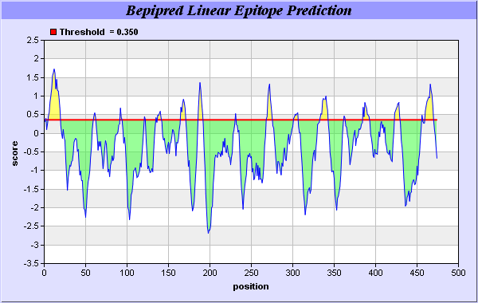
Average:-0.393 Minimum:-2.682 Maximum:1.734 Threshold:

Predicted epitopes:
No. | Start Position | End Position | Peptide | Peptide Length
1 | 2 | 2 | G | 1
2 | 5 | 19 | HQISDWDPEDSVAWE | 15
3 | 60 | 62 | GFS | 3
4 | 92 | 94 | GGR | 3
5 | 121 | 122 | PL | 2
6 | 135 | 135 | G | 1
7 | 137 | 141 | GNFAA | 5
8 | 165 | 170 | GGNLGV | 6
9 | 186 | 191 | DREPYW | 6
10 | 231 | 231 | P | 1
11 | 268 | 275 | STAQASLH | 8
12 | 301 | 306 | IGGGRV | 6
13 | 333 | 342 | GPMPTATMVG | 10
14 | 362 | 363 | YK | 2
15 | 385 | 392 | QWSRSMSG | 8
16 | 423 | 429 | ATSAFWA | 7
17 | 456 | 456 | L | 1
18 | 460 | 469 | TTAPAGLAYV | 10

