I
Sequence:
1 VAAPRLTGDQ RNAFMASFLG WTMDAFDYFL VVLVYADIAT TFHHTKTDVA FLTTATLAMR
61 PVGALLFGLW ADRVGRRVPL MVDVSFYSVI GFLCAFAPNF TVLVILRLLY GIGMGGEWGL
121 GAALSMEKVP AERRGVFSGL LQEGYAFGYL LASVAALVVM NWLGLSWRWL FGLSIIPALI
181 SLIIRYRVKE SEVWEAAQDR MRLTKTRIRD VLGNPAIVRR FVYLVLLMTA FNWMSHGTQD
241 VYPTFLTATT DHGAGLSSLT ARWIVVIYNI GAIIGGLAFG TLSQRFSRRY TIVFCAALGL
301 PIVPLFAYSR TAAMLCLGSF LMQVFVQGAW GVIPAHLTEM SPDAIRGVYP GVTYQLGNLL
361 AAFNLPIQER LAESHGYPFA LAATIVPVLL VVAVLTAIGK DATGIRFGTT ETAFLVRHRN
421 RH

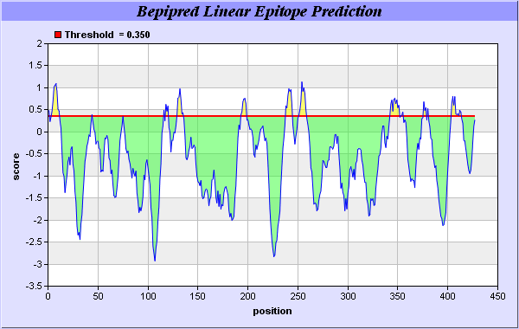

Predicted epitopes:
No. | Start Position | End Position | Peptide | Peptide Length
1 | 1 | 1 | V | 1
2 | 4 | 11 | PRLTGDQR | 8
3 | 44 | 44 | H | 1
4 | 116 | 116 | G | 1
5 | 118 | 120 | WGL | 3
6 | 129 | 135 | VPAERRG | 7
7 | 193 | 198 | VWEAAQ | 6
8 | 238 | 244 | TQDVYPT | 7
9 | 251 | 258 | DHGAGLSS | 8
10 | 342 | 351 | PDAIRGVYPG | 10
11 | 353 | 355 | TYQ | 3
12 | 376 | 378 | GYP | 3
13 | 380 | 380 | A | 1
14 | 404 | 413 | GIRFGTTETA | 10

Reference: Jens Erik Pontoppidan Larsen, Ole Lund and Morten Nielsen. Improved method for predicting linear B-cell epitopes. Immunome Res. 2006; 2: 2.

