BcePred Prediction Server

The server displays 1.GRAPHICAL RESULT 2.TABULAR RESULT 3.Overlap Display
seqname=
Seq= MPPAKKGPATSARKGQKTRRREKKNVPHGAAHIKSTFNNTIVTITDPQGNVIAWASSGHV
GFKGSRKSTPFAAQLAAENAARKAQDHGVRKVDVFVKGPGSGRETAIRSLQAAGLEVGAI
SDVTPQPHNGVRPPKRRRV
Length=139
GRAPHICAL RESULT
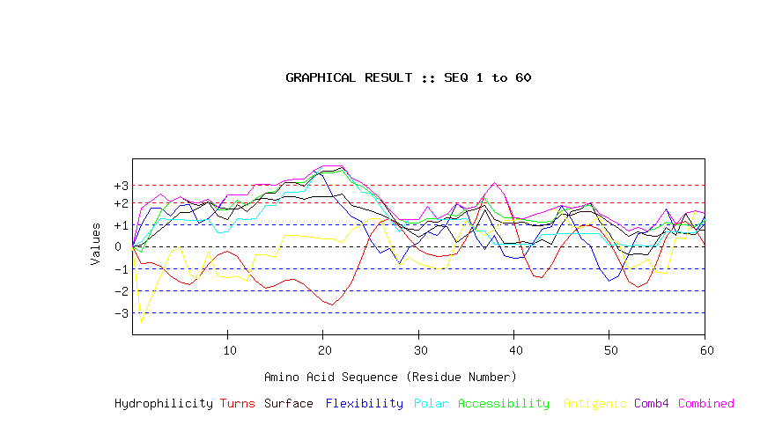
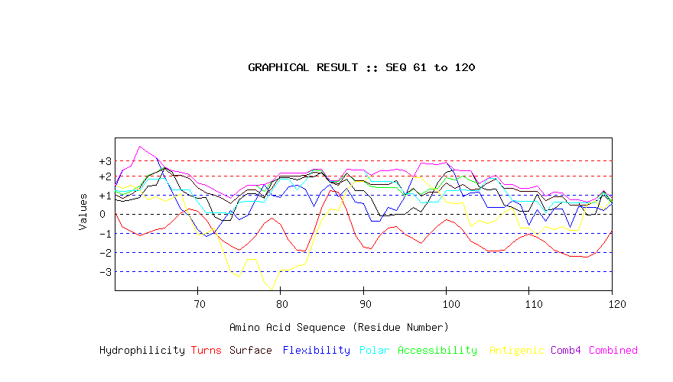
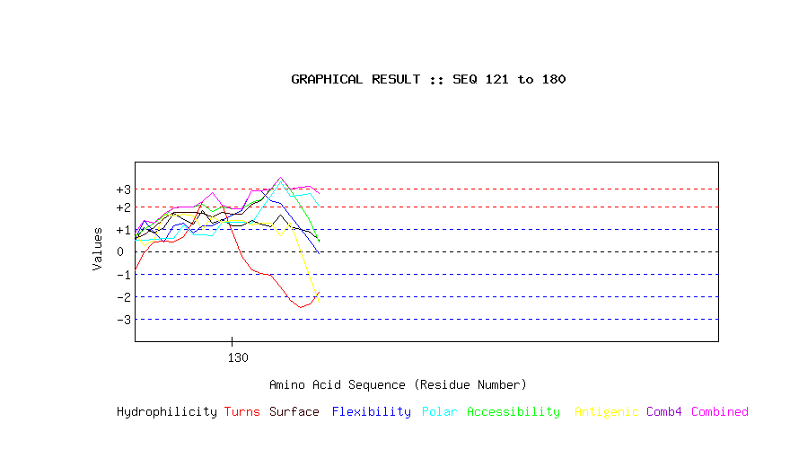
TOP

TABULAR RESULT
Selected Programs: hydro flexi access turns surface polar antipro
Respective Threshold: 1.9 2 1.9 2.4 2.3 1.8 1.9
MPPAKKGPATSARKGQKTRRREKKNVPHGAAHIKSTFNNTIVTITDPQGNVIAWASSGHV
GFKGSRKSTPFAAQLAAENAARKAQDHGVRKVDVFVKGPGSGRETAIRSLQAAGLEVGAI
SDVTPQPHNGVRPPKRRRV
Length=139
A.A. pppppppppppppppppppppppppppppp Parameter ppppppppppppppppppppppppppppppppppp Combined
Hydro Flexi Access Turns Surface Polar AntiPro MAX MIN AVG

1 M 0.054 0.992 -0.252 -0.785 1.750 0.205 -3.474 1.750 -3.474 -0.216
2 P 0.414 1.734 0.655 -0.750 2.069 0.740 -2.399 2.069 -2.399 0.352
3 P 0.775 1.734 1.561 -0.905 2.388 1.274 -1.324 2.388 -1.324 0.786
4 A 1.135 1.375 2.010 -1.355 2.023 1.214 -0.313 2.023 -1.355 0.870
5 K 1.533 1.866 2.262 -1.626 2.251 1.216 -0.038 2.262 -1.626 1.066
6 K 1.533 1.890 2.019 -1.755 1.977 1.197 -1.268 2.019 -1.755 0.799
7 G 1.729 1.058 1.973 -1.425 1.859 1.198 -1.447 1.973 -1.447 0.706
8 P 2.008 1.245 2.122 -0.822 2.014 1.218 -0.277 2.122 -0.822 1.072
9 A 1.780 1.718 1.674 -0.377 1.376 0.623 -1.353 1.780 -1.353 0.777
10 T 1.685 2.345 1.655 -0.207 1.212 0.654 -1.418 2.345 -1.418 0.846
11 S 1.685 2.345 2.113 -0.457 1.895 1.248 -1.354 2.345 -1.354 1.068
12 A 1.913 2.321 1.860 -1.084 1.576 1.229 -1.573 2.321 -1.573 0.892
13 R 2.159 2.812 2.188 -1.595 1.950 1.272 -0.400 2.812 -1.595 1.198
14 K 2.191 2.812 2.440 -1.887 2.433 1.846 -0.376 2.812 -1.887 1.351
15 G 2.109 2.794 2.487 -1.770 2.433 1.846 -0.495 2.794 -1.770 1.343
16 Q 2.241 2.980 2.917 -1.553 2.907 2.471 0.514 2.980 -1.553 1.782
17 K 2.241 3.064 2.917 -1.491 2.907 2.471 0.514 3.064 -1.491 1.803
18 T 2.147 3.064 2.898 -1.743 2.743 2.501 0.449 3.064 -1.743 1.723
19 R 2.279 3.405 3.234 -2.100 3.153 3.100 0.422 3.405 -2.100 1.928
20 R 2.260 3.200 3.356 -2.506 3.418 3.653 0.324 3.653 -2.506 1.958
21 R 2.260 2.291 3.356 -2.658 3.418 3.653 0.324 3.653 -2.658 1.806
22 E 2.374 1.836 3.459 -2.271 3.572 3.673 0.170 3.673 -2.271 1.830
23 K 1.875 1.351 2.907 -1.606 3.089 3.050 0.760 3.089 -1.606 1.632
24 K 1.742 1.147 2.720 -0.559 2.889 2.444 0.980 2.889 -0.559 1.623
25 N 1.609 0.315 2.449 0.481 2.588 2.440 1.249 2.588 0.315 1.590
26 V 1.476 -0.294 2.113 1.118 2.178 1.840 1.275 2.178 -0.294 1.387
27 P 1.249 -0.108 1.664 1.248 1.540 1.245 0.200 1.664 -0.108 1.006
28 H 1.021 -0.791 1.216 0.913 0.902 0.651 -0.875 1.216 -0.875 0.434
29 G 0.711 -0.050 1.075 0.346 0.765 1.230 -0.495 1.230 -0.495 0.512
30 A 0.440 0.179 1.057 -0.140 0.756 1.230 -0.762 1.230 -0.762 0.394
31 A 0.667 0.670 1.262 -0.343 1.121 1.806 -0.917 1.806 -0.917 0.610
32 H 0.945 0.495 1.253 -0.465 1.103 1.206 -1.024 1.253 -1.024 0.502
33 I 0.914 1.014 1.459 -0.400 1.303 1.226 -0.984 1.459 -0.984 0.647
34 K 0.199 1.948 1.393 -0.327 1.257 1.230 0.277 1.948 -0.327 0.854
35 S 0.509 1.607 1.692 0.326 1.567 1.271 1.175 1.692 0.326 1.164
36 T 0.819 0.427 1.832 1.221 1.704 0.692 0.794 1.832 0.427 1.070
37 F 1.653 -0.160 2.169 2.371 1.877 0.710 0.513 2.371 -0.160 1.305
38 N 0.787 0.505 1.580 2.905 1.221 0.117 0.770 2.905 0.117 1.127
39 N 0.142 -0.428 1.309 2.386 1.057 0.099 1.199 2.386 -0.428 0.823
40 T 0.142 -0.546 1.309 1.134 1.057 0.099 1.199 1.309 -0.546 0.628
41 I 0.218 -0.498 1.234 -0.378 1.084 0.096 1.269 1.269 -0.498 0.432
42 V 0.104 0.185 1.132 -1.339 0.929 0.075 1.423 1.423 -1.339 0.359
43 T 0.294 0.772 1.103 -1.424 0.938 0.524 1.527 1.527 -1.424 0.533
44 I 0.098 0.908 1.150 -0.821 1.057 0.523 1.706 1.706 -0.821 0.660
45 T 0.983 1.842 1.617 0.009 1.449 0.563 1.548 1.842 0.009 1.145
46 D 1.578 1.255 1.730 0.553 1.412 0.562 0.960 1.730 0.553 1.150
47 P 1.691 0.391 1.832 0.931 1.567 0.583 0.806 1.832 0.391 1.114
48 Q 1.963 0.033 1.851 0.948 1.576 0.582 1.073 1.963 0.033 1.147
49 G 1.129 -0.961 1.515 0.775 1.403 0.564 1.354 1.515 -0.961 0.825
50 N 0.629 -1.588 1.244 0.225 1.084 0.075 0.353 1.244 -1.588 0.289
51 V -0.136 -1.342 1.019 -0.589 0.829 0.081 0.155 1.019 -1.342 0.003
52 I -0.382 -0.390 0.692 -1.571 0.455 0.039 -1.018 0.692 -1.571 -0.311
53 A -0.332 0.562 0.851 -1.875 0.656 0.059 -0.859 0.851 -1.875 -0.134
54 W -0.363 0.652 0.702 -1.626 0.501 0.039 -0.586 0.702 -1.626 -0.098
55 A 0.231 1.058 0.814 -0.727 0.465 0.037 -1.175 1.058 -1.175 0.100
56 S 0.869 1.686 1.113 0.435 0.656 0.655 -1.229 1.686 -1.229 0.598
57 S 0.503 0.656 0.991 1.006 0.647 0.657 0.370 1.006 0.370 0.690
58 G 1.495 0.632 0.963 1.156 0.583 0.631 0.348 1.495 0.348 0.830
59 H 0.781 0.632 0.898 0.797 0.537 0.636 1.609 1.609 0.537 0.841
60 V 0.730 1.397 1.197 0.074 1.020 1.210 1.514 1.514 0.074 1.021
61 G 0.680 2.307 1.038 -0.688 0.820 1.190 1.355 2.307 -0.688 0.957
62 F 0.730 2.511 1.197 -0.907 1.020 1.210 1.514 2.511 -0.907 1.039
63 K 0.863 3.541 1.468 -1.137 1.321 1.215 1.246 3.541 -1.137 1.217
64 G 1.457 3.200 2.038 -0.986 1.968 1.808 0.723 3.200 -0.986 1.458
65 S 1.508 2.932 2.197 -0.814 2.169 1.828 0.882 2.932 -0.814 1.529
66 R 2.418 1.902 2.459 -0.732 2.369 1.844 0.672 2.459 -0.732 1.562
67 K 2.191 1.089 2.253 -0.392 2.005 1.268 0.827 2.253 -0.392 1.320
68 S 1.249 0.257 2.197 0.054 2.005 1.272 1.077 2.197 0.054 1.159
69 T 0.971 -0.108 2.047 0.244 1.850 1.252 -0.092 2.047 -0.108 0.881
70 P 0.838 -0.803 1.617 0.124 1.376 0.628 -1.102 1.617 -1.102 0.383
71 F 0.857 -1.162 1.496 -0.296 1.112 0.075 -1.003 1.496 -1.162 0.154
72 A -0.136 -0.987 1.262 -0.970 0.966 0.061 -0.728 1.262 -0.987 -0.076
73 A -0.332 -0.412 1.066 -1.362 0.811 0.041 -1.779 1.066 -1.779 -0.281
74 Q -0.332 0.197 0.823 -1.660 0.537 0.022 -3.009 0.823 -3.009 -0.489
75 L 0.743 -0.294 1.216 -1.880 0.948 0.617 -3.287 1.216 -3.287 -0.277
76 A 1.053 -0.090 1.515 -1.592 1.257 0.658 -2.390 1.515 -2.390 0.059
77 A 1.053 0.724 1.515 -1.144 1.257 0.658 -2.390 1.515 -2.390 0.239
78 E 0.806 1.555 1.188 -0.480 0.884 0.615 -3.563 1.555 -3.563 0.144
79 N 1.653 0.980 1.702 -0.206 1.349 1.235 -3.999 1.702 -3.999 0.388
80 A 1.881 0.862 2.150 -0.549 1.987 1.829 -2.924 2.150 -2.924 0.748
81 A 1.881 1.401 2.150 -1.393 1.987 1.829 -2.924 2.150 -2.924 0.704
82 R 1.767 1.491 2.150 -1.909 1.996 1.272 -2.734 2.150 -2.734 0.576
83 K 1.957 1.305 2.122 -1.934 2.005 1.720 -2.630 2.122 -2.630 0.649
84 A 1.957 0.377 2.281 -0.884 2.178 2.340 -1.353 2.340 -1.353 0.985
85 Q 2.185 1.191 2.272 0.305 2.132 2.340 -0.342 2.340 -0.342 1.440
86 D 1.685 1.531 1.720 1.202 1.649 1.717 0.247 1.720 0.247 1.393
87 H 1.590 0.896 1.702 1.123 1.485 1.747 0.182 1.747 0.182 1.246
88 G 1.818 1.345 2.150 0.180 2.123 2.342 1.257 2.342 0.180 1.602
89 V 1.205 0.622 1.702 -1.097 1.741 2.301 1.682 2.301 -1.097 1.165
90 R 1.205 0.544 1.702 -1.727 1.741 2.301 1.682 2.301 -1.727 1.064
91 K 0.838 -0.366 1.421 -1.813 1.558 1.683 2.003 2.003 -1.813 0.761
92 V -0.104 -0.366 1.365 -1.150 1.558 1.687 2.254 2.254 -1.150 0.749
93 D -0.104 0.357 1.365 -0.722 1.558 1.687 2.254 2.254 -0.722 0.914
94 V -0.009 0.177 1.384 -0.660 1.722 1.657 2.320 2.320 -0.660 0.942
95 F -0.009 0.900 0.926 -1.048 1.039 1.062 2.256 2.256 -1.048 0.732
96 V 0.357 1.930 1.290 -1.314 1.321 1.080 1.887 1.930 -1.314 0.936
97 K 0.085 2.653 1.010 -1.530 0.957 0.591 1.896 2.653 -1.530 0.809
98 G 0.730 2.635 1.281 -1.040 1.121 0.609 1.467 2.635 -1.040 0.972
99 P 1.672 2.583 1.337 -0.618 1.121 0.605 1.216 2.583 -0.618 1.131
100G 2.172 2.715 1.889 -0.295 1.604 1.228 0.627 2.715 -0.295 1.420
101S 2.305 2.088 1.767 -0.463 1.330 1.233 0.535 2.305 -0.463 1.257
102G 2.273 0.908 1.973 -0.853 1.531 1.253 0.576 2.273 -0.853 1.094
103R 2.273 1.095 1.730 -1.402 1.257 1.234 -0.654 2.273 -1.402 0.790
104E 1.407 1.137 1.599 -1.663 1.285 1.236 -0.333 1.599 -1.663 0.667
105T 1.261 0.357 1.879 -1.959 1.604 1.840 -0.494 1.879 -1.959 0.641
106A 1.312 0.357 2.038 -1.926 1.804 1.861 -0.334 2.038 -1.926 0.730
107I 0.465 0.357 1.524 -1.908 1.339 1.241 0.102 1.524 -1.908 0.446
108R 0.351 0.682 1.524 -1.518 1.349 0.684 0.291 1.524 -1.518 0.480
109S 0.155 0.495 1.328 -1.227 1.194 0.664 -0.760 1.328 -1.227 0.264
110L 0.155 -0.564 1.328 -1.043 1.194 0.664 -0.760 1.328 -1.043 0.139
111Q 1.021 0.215 1.459 -1.210 1.166 0.662 -1.081 1.459 -1.210 0.319
112A 0.174 -0.372 0.945 -1.500 0.701 0.043 -0.645 0.945 -1.500 -0.093
113A 0.256 0.255 1.122 -1.912 0.911 0.623 -0.831 1.122 -1.912 0.061
114G 0.604 0.255 1.085 -2.066 0.893 0.619 -0.677 1.085 -2.066 0.102
115L 0.585 -0.697 0.748 -2.210 0.474 0.576 -0.840 0.748 -2.210 -0.195
116E 0.585 0.363 0.748 -2.222 0.474 0.576 -0.840 0.748 -2.222 -0.045
117V -0.054 0.327 0.608 -2.251 0.455 0.578 0.491 0.608 -2.251 0.022
118G -0.003 0.327 0.767 -2.050 0.656 0.598 0.651 0.767 -2.050 0.135
119A 1.211 0.191 1.122 -1.541 0.966 1.082 0.207 1.211 -1.541 0.462
120I 0.484 0.550 0.674 -0.840 0.592 0.484 0.822 0.822 -0.840 0.395
121S 1.046 1.365 0.991 -0.046 0.756 0.502 0.274 1.365 -0.046 0.698
122D 0.819 0.868 1.244 0.423 1.075 0.521 0.494 1.244 0.423 0.778
123V 1.065 0.419 1.571 0.462 1.449 0.564 1.667 1.667 0.419 1.028
124T 1.704 1.125 1.954 0.430 1.741 0.581 1.565 1.954 0.430 1.300
125P 1.426 1.261 1.963 0.645 1.759 1.181 1.673 1.963 0.645 1.415
126Q 1.236 0.806 1.991 1.350 1.750 0.732 1.569 1.991 0.732 1.348
127P 1.830 1.129 2.103 2.212 1.713 0.731 0.980 2.212 0.731 1.528
128H 1.268 1.129 1.786 2.615 1.549 0.712 1.528 2.615 0.712 1.512
129N 1.401 1.397 1.973 2.049 1.750 1.318 1.308 2.049 1.308 1.599
130G 1.154 1.619 1.889 0.912 1.649 1.295 1.364 1.889 0.912 1.412
131V 1.154 1.806 1.889 -0.218 1.649 1.295 1.364 1.889 -0.218 1.277
132R 1.382 2.715 2.178 -0.806 2.114 1.269 1.162 2.715 -0.806 1.431
133P 1.205 2.715 2.309 -0.972 2.278 1.853 1.274 2.715 -0.972 1.523
134P 1.110 2.261 2.748 -1.076 2.798 2.478 1.273 2.798 -1.076 1.656
135K 1.609 2.156 3.300 -1.597 3.281 3.101 0.683 3.300 -1.597 1.790
136R 1.110 1.579 2.748 -2.186 2.798 2.478 1.273 2.798 -2.186 1.400
137R 0.977 1.020 2.047 -2.502 2.843 2.519 0.043 2.843 -2.502 0.993
138R 0.844 0.461 1.346 -2.360 2.889 2.560 -1.187 2.889 -2.360 0.651
139V 0.484 -0.098 0.440 -1.805 2.570 2.026 -2.262 2.570 -2.262 0.193

TOP

Overlap Display
Selected Programs: hydro flexi access turns surface polar antipro
Respective Threshold: 1.9 2 1.9 2.4 2.3 1.8 1.9
The predicted B-cell epitopes are shown in blue colour and underlined.
Sequence | ¹MPPAKKGPATSARKGQKTRRREKKNVPHGAAHIKSTFNNTIVTITDPQGNVIAWASSGHVGFKGSRKSTPFAAQLAAENAARKAQDHGVRKVDVFVKGPGSGRETAIRSLQAAGLEVGAISDVTPQPHNGVRPPKRRRV¹³⁹
Hydrophilicity | ¹MPPAKKGPATSARKGQKTRRREKKNVPHGAAHIKSTFNNTIVTITDPQGNVIAWASSGHVGFKGSRKSTPFAAQLAAENAARKAQDHGVRKVDVFVKGPGSGRETAIRSLQAAGLEVGAISDVTPQPHNGVRPPKRRRV¹³⁹
Flexibility | ¹MPPAKKGPATSARKGQKTRRREKKNVPHGAAHIKSTFNNTIVTITDPQGNVIAWASSGHVGFKGSRKSTPFAAQLAAENAARKAQDHGVRKVDVFVKGPGSGRETAIRSLQAAGLEVGAISDVTPQPHNGVRPPKRRRV¹³⁹
Accessibility | ¹MPPAKKGPATSARKGQKTRRREKKNVPHGAAHIKSTFNNTIVTITDPQGNVIAWASSGHVGFKGSRKSTPFAAQLAAENAARKAQDHGVRKVDVFVKGPGSGRETAIRSLQAAGLEVGAISDVTPQPHNGVRPPKRRRV¹³⁹
Turns | ¹MPPAKKGPATSARKGQKTRRREKKNVPHGAAHIKSTFNNTIVTITDPQGNVIAWASSGHVGFKGSRKSTPFAAQLAAENAARKAQDHGVRKVDVFVKGPGSGRETAIRSLQAAGLEVGAISDVTPQPHNGVRPPKRRRV¹³⁹
Exposed Surface | ¹MPPAKKGPATSARKGQKTRRREKKNVPHGAAHIKSTFNNTIVTITDPQGNVIAWASSGHVGFKGSRKSTPFAAQLAAENAARKAQDHGVRKVDVFVKGPGSGRETAIRSLQAAGLEVGAISDVTPQPHNGVRPPKRRRV¹³⁹
Polarity | ¹MPPAKKGPATSARKGQKTRRREKKNVPHGAAHIKSTFNNTIVTITDPQGNVIAWASSGHVGFKGSRKSTPFAAQLAAENAARKAQDHGVRKVDVFVKGPGSGRETAIRSLQAAGLEVGAISDVTPQPHNGVRPPKRRRV¹³⁹
Antigenic Propensity | ¹MPPAKKGPATSARKGQKTRRREKKNVPHGAAHIKSTFNNTIVTITDPQGNVIAWASSGHVGFKGSRKSTPFAAQLAAENAARKAQDHGVRKVDVFVKGPGSGRETAIRSLQAAGLEVGAISDVTPQPHNGVRPPKRRRV¹³⁹

TOP

Home

